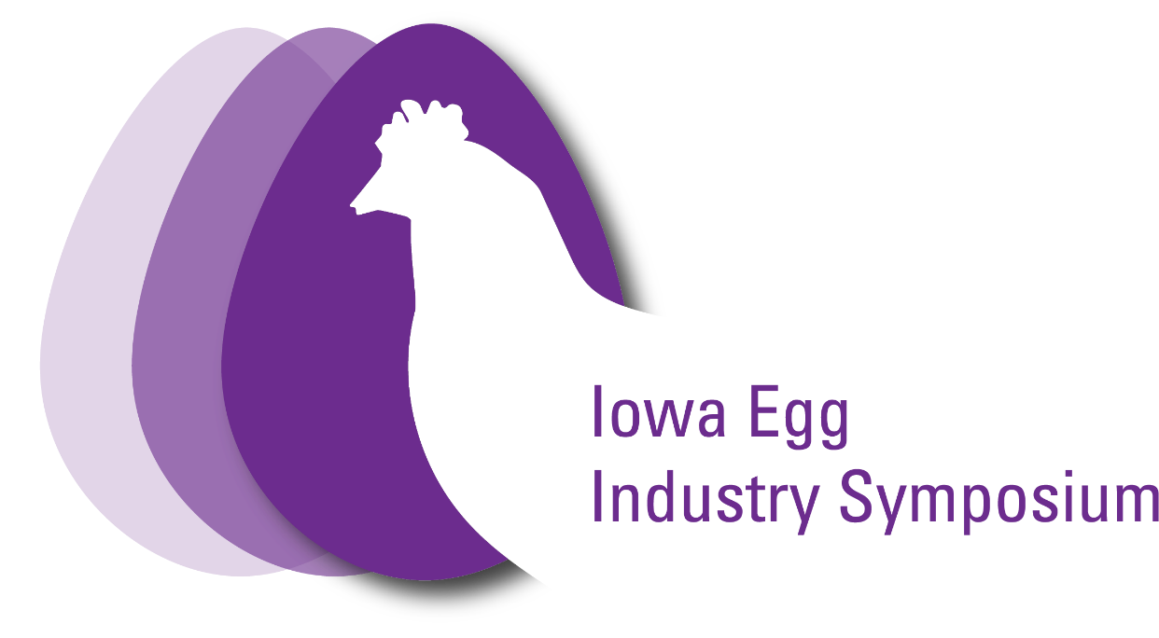

Iowa Egg Industry Symposium Continuing Education Verification

This verifies that _________________________________ was registered for the 2022 Iowa Egg Industry Symposium in Ames, Iowa on November 10th, 2022.

This certifies that the individual above has received 4.75 hours of scientific continuing education credit contact hours for attendance from the Iowa Board of Veterinary Medicine.

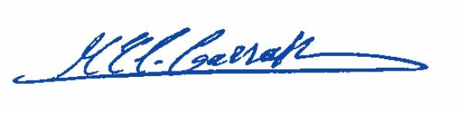
Iowa Egg Industry Symposium coordinating staff
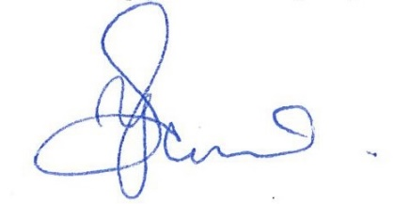
Yuko Sato Mohamed El-Gazzar

